**Functional Document**

|  |  |
| --- | --- |
| **Application** | NGERP - Cenra |
| **Service Bundle** | Sales Management |
| **Service Request** | Sales Order Approval |

**Description:**

In **Compiere (NGERP - Centra),** the "**Sales Order Approval**" screen is a key feature that helps users manage and review sales order transactions before they are finalized.

**Workflow Process:**

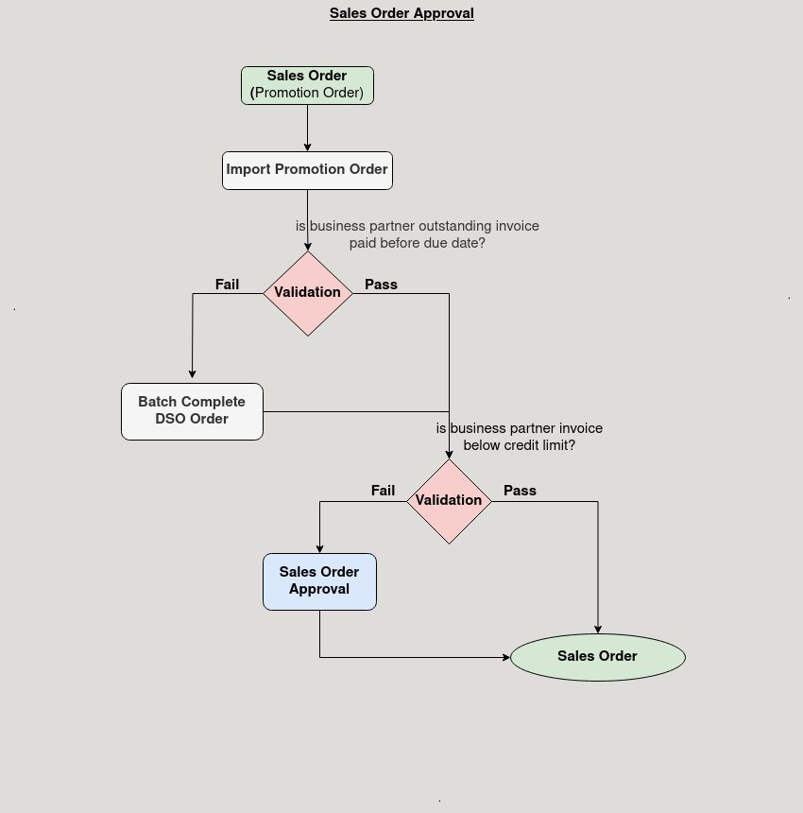

**Business Rules:**

* It is visible in Both **HQ** and **ROW.**
* In **HQ** all region Sales order will be shown.
* Credit limit exceded **Sales Order** will be shown here.
* Here, the **approval** for the sales will be done.
* After approval sales order will be shown in **Sales Order page.**